BRAND POSITIONING DOCUMENT · CONFIDENTIAL
shroomé
The world's first ready-to-pour liquid ceremonial matcha latte, infused with grass-fed collagen and organic mushroom beta glucans.
POUR / SWIRL / GLOW

01 — NORTH STAR
The North Star

Every iconic brand is built on a single, irreducible truth. Before the logo, before the flavor, before the packaging — this is Shroomé's.

Shroomé exists to make the most sophisticated morning ritual on earth completely effortless — organic ceremonial matcha, grass-fed collagen, and clinically-backed mushroom beta glucans in a single, ready-to-pour bottle. No mixer. No barista. No excuses.

THE INSIGHT
The functional wellness consumer has been forced to choose between convenience and quality for too long. Clevr made instant lattes respectable. Bloom made wellness approachable. Poppi made gut health fun. Shroomé goes further — it delivers a genuine ceremonial-grade, multi-functional, beauty-and-immunity stack that requires zero effort. The ritual is: pour, swirl, glow.

02 — RITUAL ARCHITECTURE
The Ritual Architecture

Three words define every touchpoint of this brand — from the bottle form to the copy to the community. Not just instructions. A promise.

STEP ONE  Pour  No hand mixer. No frother. No powder clumps at 6am. Shroomé is ready-to-pour liquid concentrate — the moment you crack the cap, the ritual has begun. It's already done for you. |  | STEP TWO  Swirl  Over ice, into oat milk, into hot water — Shroomé swirls like a dream. The collagen keeps it silky. The matcha keeps it vivid. The green pouring through white is the TikTok moment that markets itself. |  | THE OUTCOME  Glow  Collagen for skin elasticity. Beta glucan polysaccharides for immune modulation. EGCG antioxidants for cellular protection. The glow isn't a metaphor — it's a clinical outcome dressed as a lifestyle brand.

03 — WHAT SHROOME DELIVERS
What Shroome Delivers

The value architecture is five layers deep. Each layer is a moat. Together they form a product that is genuinely, category-defyingly different.

01 | Liquid-Ready Format  CATEGORY CREATION | Every competitor — Clevr, Laird, RYZE, MUD\WTR — is a powder. Shroomé is the first liquid ceremonial matcha latte concentrate. Just as cold brew changed coffee, Shroomé changes matcha. The category is yours to define.
02 | Ceremonial-Grade Integrity  SOURCING INTEGRITY | Most functional matcha brands use culinary-grade because authentic ceremonial is expensive. Shroomé refuses to compromise. Single-origin, stone-ground, organic — the highest EGCG concentration, cleanest L-theanine, and that unmistakable vivid jade color.
03 | Grass-Fed Collagen  BEAUTY-WELLNESS BRIDGE | Collagen is the fastest-growing functional ingredient in the US, yet no matcha brand has integrated it at liquid formulation level. Pre-dissolved directly into the matrix — optimized absorption, no clumping. The morning beauty ritual and the wellness ritual, collapsed into one pour.
04 | FDA GRAS Mushroom Beta Glucans  REGULATORY EDGE | The mushroom space is noisy. Shroomé's differentiator: FDA GRAS-designated, food-grade beta glucan polysaccharides at clinically-informed doses. Not a blend. Not an extract. Specific, bioactive, defensible — the narrative that wins the wellness-informed consumer.
05 | The Stack  STACK COMPRESSION | Ceremonial matcha (energy + cognition) + collagen (skin + joints) + mushroom beta glucans (immunity + metabolic health). Three products the consumer already buys separately, collapsed into one delicious, ready-to-pour morning ritual.

04 — BRAND DNA
Brand DNA

The four pillars that inform every decision — packaging, copy, partnership, channel, content, and culture.

PILLAR ONE  Ceremonial Without the Ceremony  We honor the Japanese matcha tradition absolutely — only organic, stone-ground, ceremonial-grade leaves — but refuse to gatekeep it. The ritual is precious; the preparation is not. The product respects the origin. The format respects your morning. |  | PILLAR TWO  Science That Doesn't Sound Like Science  FDA GRAS beta glucans. Grass-fed collagen peptides. EGCG catechins from ceremonial shade-grown leaves. The formulation is rigorous and defensible at every level. But Shroomé communicates like a lifestyle brand with receipts — the science lives in the ingredient story, not the front panel claim.
PILLAR THREE  Effortless Is the Luxury  Luxury used to mean more steps. More tools. More preparation. The new luxury is the opposite: something this good, already done for you. The ready-to-pour format isn't a convenience feature — it's the brand's core philosophy. You don't need to earn a good morning. |  | PILLAR FOUR  Beauty Is a Health Outcome  Shroomé bridges the supplement aisle and the skincare counter. Collagen and beta-1,3/1,6 glucans support skin elasticity, immune modulation, and cellular health. Glowing skin isn't vanity — it's a biomarker. Shroomé is the first matcha brand to own beauty outcomes as a formulation promise.

05 — WHO SHE IS
Who She Is

The Shroomé consumer exists at a precise cultural intersection. She's already spending money across this stack — she just doesn't know she can get it all from one bottle yet.

The Ritual Optimizer  SHE / 27–38 / URBAN  + Has a matcha habit, probably from a café or Clevr  + Adds collagen to her coffee separately  + Bought RYZE once, liked the idea, not the taste  + Follows @wellness, @skincare, @gut health creators  + Spends $80–$150/mo on supplements and functional foods  "I just want my morning to be simpler without giving anything up." |  | The Wellness Curator  SHE / 32–45 / SUBURBAN + DTC  + Buys Graza, Acid League, Brightland — aesthetics matter  + Approaches supplements with informed skepticism  + Pays premium for clean labels and source transparency  + FDA GRAS designation matters to her  + The bottle lives on the counter, not in the cabinet  "If it's going into my body every day, the ingredients have to be real and the brand has to be honest." |  | The Glow Chaser  SHE OR HE / 22–35 / SOCIAL-FIRST  + Discovered matcha on TikTok, follows drink aesthetics creators  + Interested in skin health — collagen is familiar  + The swirl moment is the content moment  + Converts via visual — the green pour into white milk  + First to post, repost, and gift it  "It's the most aesthetic thing in my fridge and it actually makes me feel good."

06 — COMPETITIVE LANDSCAPE
The Competitive Landscape

Who's playing in adjacent spaces, what they own, and exactly where Shroomé wins.

SHROOME
Ready-to-Pour Liquid Matcha Latte · Collagen · Mushroom Beta Glucans
The stack, already made. Just pour.
Organic ceremonial matcha + grass-fed collagen + FDA GRAS mushroom beta glucans in a ready-to-pour liquid latte. No mixing, no powders, no separate supplements. The only brand that compresses a three-part morning wellness ritual into a single bottle — and makes it look gorgeous doing it.
* OUR UNFAIR ADVANTAGE

CLEVR BLENDS  Made the functional latte category credible  Clevr proved that functional latte mixes can be beautiful and Oprah-worthy. Their matcha SuperLatte is excellent — ceremonial grade, adaptogens. But it's still a powder. Still needs a frother. And it's vegan — no collagen. Clevr's consumer overlaps deeply with Shroomé's, which is good: they've done expensive category education for us.  CLOSEST COUSIN |  | RYZE / FOUR SIGMATIC  Popularized mushrooms, but lost the plot on taste  RYZE pulls $200M+ in revenue. But both brands are powder-based, mushroom-first, where the drink experience is secondary to the supplement claim. Reviews consistently flag mediocre taste. Shroomé offers everything they offer, plus a genuinely delicious drink, plus collagen, in a liquid format.  SAME INGREDIENT, DIFFERENT UNIVERSE

LAIRD SUPERFOOD  Performance-first, missing the beauty hook  Strong ingredient credibility and performance-wellness positioning. But Laird's aesthetic is athletic and utilitarian — it lives in the gym bag, not on the vanity shelf. No collagen. No liquid format. No beauty narrative. Their consumer skews male and performance-driven.  ADJACENT, NOT COMPETING |  | MATCHAKO  RTD matcha, but purely a beverage play  MatchaKo is the closest format competitor — liquid, ceremonial grade, RTD. But they're a beverage brand, not a wellness brand. No collagen. No mushrooms. No functional stack. The liquid format gives Shroomé something to point to as proof of concept, while our stack creates the premium pricing and repurchase rationale that RTD matcha alone cannot command.  FORMAT COUSIN, DIFFERENT MISSION

BLOOM NUTRITION  The community-first playbook at its best  Not a direct competitor but the best brand blueprint for Shroomé's growth path. Founder Mari Llewellyn built a community before a product line, leveraged TikTok at scale, and expanded from greens powder to $200M+ in revenue in under four years. The lesson: charismatic founder story + great formulation + community-first marketing creates compounding brand equity.  ASPIRATION COMP |  | GRAZA  Premium quality, unfussy format, everyday flex  Graza didn't invent olive oil — they reinvented the format. A squeeze bottle that says 'use me every day, don't save me for special occasions.' Shroomé's ready-to-pour bottle is Graza's squeeze bottle. Own the format, own the occasion. The everyday-premium positioning is exactly the same play.  STRATEGIC BLUEPRINT

07 — MOAT MAP
The Moat Map

Shroomé's competitive advantages at a glance. Where everyone else falls short.

BRAND | LIQUID RTD | CEREMONIAL MATCHA | COLLAGEN | GRAS MUSHROOMS | BEAUTY NARRATIVE
Shroome | YES | YES | YES | YES | YES
Clevr Blends | NO | YES | NO | ~ | ~
RYZE | NO | NO | NO | ~ | NO
Four Sigmatic | NO | ~ | NO | ~ | NO
Laird Superfood | NO | ~ | NO | ~ | NO
MatchaKo | YES | YES | NO | NO | NO

YES = Full · ~ = Partial · NO = None

08 — BRAND WORLD & ECOSYSTEM
Brand World & Ecosystem

The cultural neighborhood Shroomé lives in — the brands that shaped the world we're entering, and how we carve our own lane within it.

Vacation  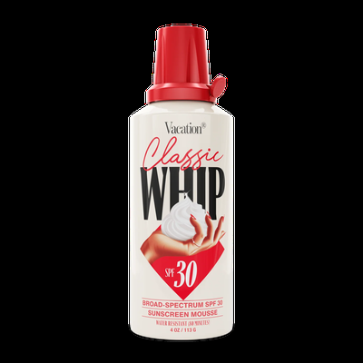  WE BORROW  Made a commodity category feel like a personality — nostalgia-forward design, pure unabashed fun  HOW WE DIVERGE  Grounded and earthy where Vacation is retro-sunny. We calm and center; they amplify and excite. |  | Erewhon  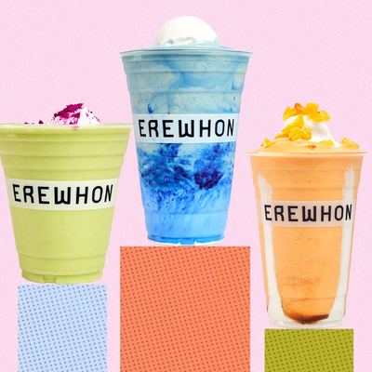  WE BORROW  Aspirational wellness as lifestyle status — the cultural validator every serious wellness brand covets  HOW WE DIVERGE  Accessible at a real price point — all the Erewhon energy without the $22 smoothie tax.

Recess  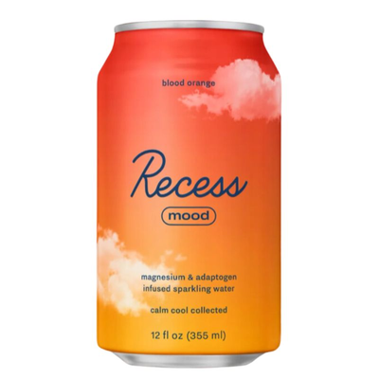  WE BORROW  Calm as an identity. Cloud-soft visual language that made anxiety-reduction beautiful and share-worthy  HOW WE DIVERGE  Warmer and earthier; less pastel-digital, more grounded morning ritual. Recess is afternoon; Shroomé is dawn. |  | Kin Euphorics  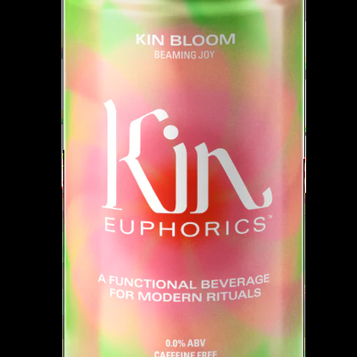  WE BORROW  Mystical, premium functional drinks — made going alcohol-free feel elevated instead of absent  HOW WE DIVERGE  More playful and food-forward; Kin owns the nightcap, Shroomé owns the morning.

Clevr Blends  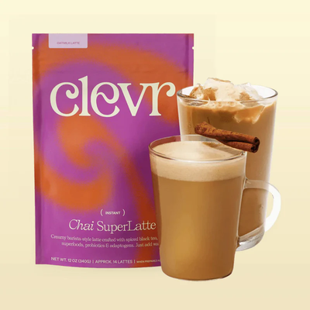  WE BORROW  Warm, earthy premium latte format — proved functional lattes can be Oprah-worthy  HOW WE DIVERGE  More brand-loud and craveable — designed to live on the counter, not hidden in the pantry. |  | Graza  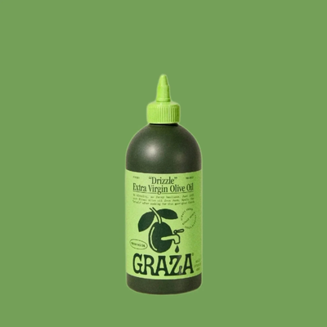  WE BORROW  Turned a pantry staple into a counter object and a giftable icon via format innovation alone  HOW WE DIVERGE  Same squeeze-bottle philosophy: own the format, own the occasion. Graza owns dinner; we own mornings.

Jubi  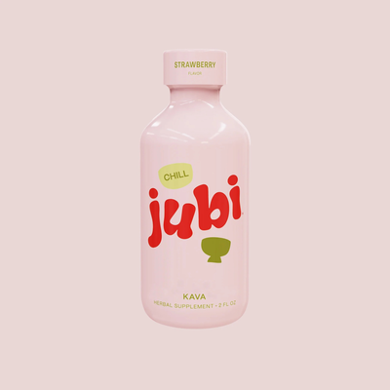  WE BORROW  Playful, bold, Gen Z-coded packaging that makes functional feel joyful, not clinical  HOW WE DIVERGE  More ritual and slow-morning; less on-the-go shot format. More counter object, less pocket-grab. |  | Bloom  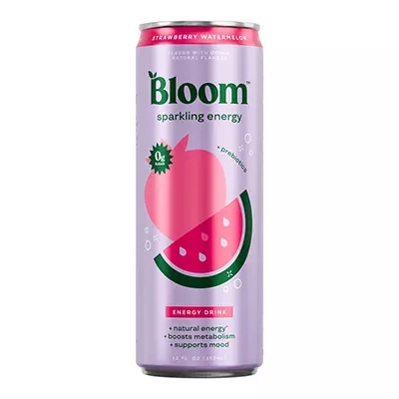  WE BORROW  Built a massive Gen Z community around functional wellness — the community-first playbook at its best  HOW WE DIVERGE  More elevated and intimate. Bloom is mass and loud; Shroomé is considered, craveable, and curated.

Olipop  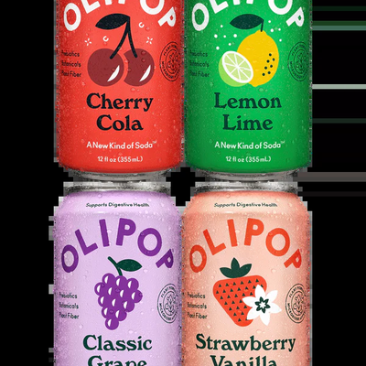  WE BORROW  Proved that functional benefits + irresistible branding can drive a $1.85B valuation and genuine cultural love  HOW WE DIVERGE  Quieter and ritual-focused — mornings not afternoons, concentrated depth not sparkling refreshment. |  | Glossier  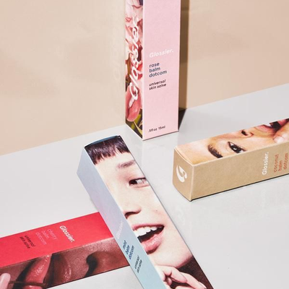  WE BORROW  Radical community intimacy and skin-first philosophy — built a brand you follow before you ever buy  HOW WE DIVERGE  We apply that intimacy to a daily ingestible ritual. Same closeness, different medium.

09 — VOICE & TONE
Voice & Tone

How Shroomé speaks — and importantly, how it does not.

WE SOUND LIKE  Knowledgeable, Warm, Unfussy  We know our ingredients inside out — but share that knowledge like a smart friend who happens to be a formulation scientist. Confident without being clinical. Warm without being saccharine.  + "No hand mixer needed" — not "eliminates preparation friction"  + "Your glow is in the bottle" — not "supports dermal collagen synthesis"  + "The ritual is ready, just pour" — not "optimized for bioavailability" |  | WE NEVER SOUND LIKE  Preachy, Vague, or Supplement-Coded  No "unlock your potential." No "nourish your soul." No excessive jargon on the front panel. No before-and-after language. We are a beverage brand with receipts — not a supplement brand doing a beverage play.  + "Hack your morning routine"  + "Unlock your potential"  + "Clinically proven to optimize performance"

THE COPY TEST
If it could appear on a Clevr, Graza, or Poppi piece of content and feel at home — we're close. If it sounds like a GNC label or a wellness blog from 2018 — we rewrite it. Shroomé is a brand you'd follow on Instagram before you ever buy a bottle. The content earns the sale.

The ritual is ready. Just pour.
Shroome / Pour / Swirl / Glow / Brand DNA v1.0

